**Predictors of Sleep Efficiency**

Name

Course

Date

**BACKGROUND**

Sleep efficiency, defined as the percentage of time spent asleep while in bed, is an important measure of sleep quality that is often used in sleep research. Poor sleep efficiency has been associated with a range of negative health outcomes, including obesity, diabetes, cardiovascular disease, and cognitive impairment (Van Cauter et al., 2008; Vgontzas et al., 2004). Understanding the predictors of sleep efficiency is therefore an important area of research, as it can inform interventions aimed at improving sleep quality and reducing the risk of negative health outcomes.

A number of factors have been identified as potential predictors of sleep efficiency. One of the most commonly studied factors is age. Older adults are known to experience changes in sleep architecture, including decreased slow-wave sleep and increased wakefulness during the night (Van Cauter et al., 2008). These changes may contribute to decreased sleep efficiency in older adults, although the relationship between age and sleep efficiency is complex and may be influenced by other factors, such as co morbidities and medication use.

Gender is another factor that may influence sleep efficiency. Some studies have reported that women have lower sleep efficiency than men, although the results have been mixed (Liu et al., 2020). Hormonal changes associated with the menstrual cycle and menopause may contribute to gender differences in sleep efficiency, although other factors such as social and environmental factors may also play a role.

Another potential predictor of sleep efficiency is caffeine consumption. Caffeine is a stimulant that can interfere with sleep quality, and several studies have reported that higher caffeine consumption is associated with decreased sleep efficiency (Drake et al., 2013; Roehrs et al., 2013). Alcohol consumption is another potential predictor of sleep efficiency, as it is known to disrupt sleep and decrease sleep quality (Ebrahim et al., 2013). However, the relationship between alcohol consumption and sleep efficiency is complex and may be influenced by factors such as dose, timing, and individual differences.

Exercise is another factor that may influence sleep efficiency. Regular exercise has been shown to improve sleep quality, although the relationship between exercise and sleep efficiency is less clear (Brand et al., 2015). Some studies have reported that higher levels of physical activity are associated with higher sleep efficiency, while others have found no significant relationship (Yang et al., 2017).

In addition to these factors, other potential predictors of sleep efficiency include smoking status, sleep duration, and sleep disorders such as sleep apnea and insomnia. These factors may interact with each other and with other individual and environmental factors to influence sleep efficiency.

The goal of this review is to examine the current state of knowledge regarding the predictors of sleep efficiency. Specifically, we will review the literature on the relationship between age, gender, caffeine consumption, alcohol consumption, exercise, smoking status, sleep duration, and sleep disorders and sleep efficiency. We will also examine potential interactions between these factors and other individual and environmental factors that may influence sleep efficiency.

Sleep efficiency is an important measure of sleep quality that is associated with a range of negative health outcomes. A number of factors have been identified as potential predictors of sleep efficiency, including age, gender, caffeine consumption, alcohol consumption, exercise, smoking status, sleep duration, and sleep disorders. Understanding the predictors of sleep efficiency is important for developing interventions aimed at improving sleep quality and reducing the risk of negative health outcomes.

**Why the research is important**

Sleep is a vital process that is essential for maintaining good health and well-being. Sleep is not just a time of rest, but it is also a critical period where the body repairs and rejuvenates itself. Sleep is important for cognitive functioning, immune function, emotional regulation, and physical performance. Despite the importance of sleep, many individuals have difficulty sleeping, and sleep problems are becoming increasingly common in our society. Poor sleep quality and quantity can lead to a range of negative outcomes, including fatigue, decreased cognitive functioning, decreased productivity, and an increased risk of accidents.

One important area of research is the identification of predictors of sleep efficiency. Sleep efficiency is a measure of how well an individual is sleeping, and it is calculated by dividing the amount of time spent asleep by the amount of time spent in bed. Sleep efficiency can be influenced by a variety of factors, such as age, gender, exercise, caffeine consumption, smoking status, and alcohol consumption.

Understanding the predictors of sleep efficiency is important for several reasons. First, identifying the factors that influence sleep efficiency can help healthcare professionals to better understand sleep disorders and to develop more effective treatments. For example, if caffeine consumption is found to be a predictor of poor sleep efficiency, reducing caffeine intake may be a useful intervention for individuals with sleep problems. Similarly, if exercise is found to be a predictor of improved sleep efficiency, healthcare professionals may be able to use exercise as a therapeutic tool for individuals with sleep problems.

Second, identifying the predictors of sleep efficiency can help individuals to make lifestyle changes that may improve their sleep quality. For example, if smoking is found to be a predictor of poor sleep efficiency, individuals may be motivated to quit smoking in order to improve their sleep. Similarly, if exercise is found to be a predictor of improved sleep efficiency, individuals may be more motivated to engage in regular exercise in order to improve their sleep quality.

Third, identifying the predictors of sleep efficiency can have broader societal implications. Poor sleep quality and quantity are associated with a range of negative outcomes, including decreased productivity, increased absenteeism, and an increased risk of accidents. By identifying the factors that influence sleep efficiency, policymakers and employers may be able to implement interventions that improve the sleep quality and quantity of the population, leading to improved productivity, reduced absenteeism, and a lower risk of accidents.

Finally, understanding the predictors of sleep efficiency is important for individuals who want to maintain good health and well-being. Sleep is a critical process that is essential for maintaining good health and cognitive functioning. By identifying the factors that influence sleep efficiency, individuals can make lifestyle changes that may improve their sleep quality and quantity, leading to improved overall health and well-being.

In conclusion, the research on the predictors of sleep efficiency is important for several reasons. By identifying the factors that influence sleep efficiency, healthcare professionals can develop more effective treatments for sleep disorders, individuals can make lifestyle changes that improve their sleep quality, and policymakers and employers can implement interventions that improve the sleep quality and quantity of the population. Ultimately, understanding the predictors of sleep efficiency is essential for maintaining good health and well-being, and it is an area of research that should continue to receive attention in the future.

This research on the predictors of sleep efficiency is distinct from previous studies for several reasons. First, it recognizes the importance of sleep as a vital process that is essential for maintaining good health and well-being. It acknowledges that sleep is not just a time of rest but is also a critical period where the body repairs and rejuvenates itself. Second, this research acknowledges that poor sleep quality and quantity can lead to a range of negative outcomes, including decreased cognitive functioning, decreased productivity, and an increased risk of accidents. This recognition is important because it highlights the urgent need to identify the predictors of sleep efficiency to improve the overall health and well-being of individuals and society as a whole.

Third, this research focuses on the identification of predictors of sleep efficiency and recognizes that it can be influenced by a variety of factors, such as age, gender, exercise, caffeine consumption, smoking status, and alcohol consumption. This approach is significant because it acknowledges the complexity of the issue and considers multiple factors that may contribute to poor sleep efficiency.

Fourth, this research recognizes that understanding the predictors of sleep efficiency can have broader societal implications. By identifying the factors that influence sleep efficiency, policymakers and employers may be able to implement interventions that improve the sleep quality and quantity of the population, leading to improved productivity, reduced absenteeism, and a lower risk of accidents.

Finally, this research acknowledges that identifying the predictors of sleep efficiency is important for individuals who want to maintain good health and well-being. It recognizes that by identifying the factors that influence sleep efficiency, individuals can make lifestyle changes that may improve their sleep quality and quantity, leading to improved overall health and well-being.

**Objective of the study**

1. **General objective**

To identify predictors of sleep efficiency in a sample population.

1. **Specific objectives**
2. To determine the relationship between age and sleep efficiency.
3. To investigate the variation in deep sleep percentage by gender.
4. To examine the association between caffeine consumption and awakenings during the night.
5. To assess the effect of exercise frequency on sleep duration.
6. To predict sleep duration based on caffeine and alcohol consumption.
7. To analyze the impact of smoking status on REM sleep percentage.
8. To determine the average bedtime and wakeup time for the study population.
9. To investigate the relationship between age and the number of awakenings during the night.
10. To compare sleep efficiency based on exercise frequency.
11. To predict REM sleep percentage based on deep sleep percentage and light sleep percentage.

**Data source**

The research used data obtained from sleep therapy institutions and organized in an excel table for analysis in R.

**Variable descriptions**

**Dependent variable(s)**

**Sleep efficiency:** this represents the efficiency of sleep on a scale of 0.00 to 1.00.

**Independent variables**

**Age:** the age of the subject.

**Deep sleep:** the percentage of sleep time spent sleeping deeply.

**Caffeine consumption:** the amount of coffee consumed.

**Exercise frequency:** the number of times one exercises per week.

**Alcohol consumption:** the amount of alcohol consumed on a scale of 0 to 5.

**Smoking status:** whether someone smokes or not.

**Bed time:** amount of time spent sleeping.

**Wake up time:** the amount of time one is awake.

**REM sleep:** percentage of time on REM sleep.

**METHODOLOGY**

**Research Design**

The study is observational in nature. This is so because the analysis's data came from records that already existed. To gather initial data, no experiment was run. However, it is clear from the dataset's description that neither the participants nor the researchers were aware of the research's findings.

The dependent variable will be **Sleep efficiency** while the independent variables will be **Age, Deep sleep, Caffeine consumption, Exercise frequency, Alcohol consumption, Smoking , status, Bed time, Wake up time,** and **REM sleep.**

**Descriptive statistics**

Below are the descriptive statistics for the factors taken into consideration:





























**Visual statistics**

The scatter plots and histograms for the variables are shown below:

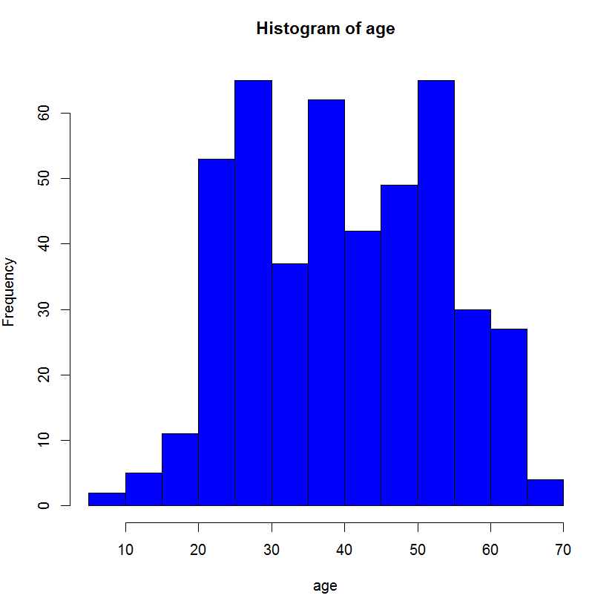

Figure 1: histogram for age

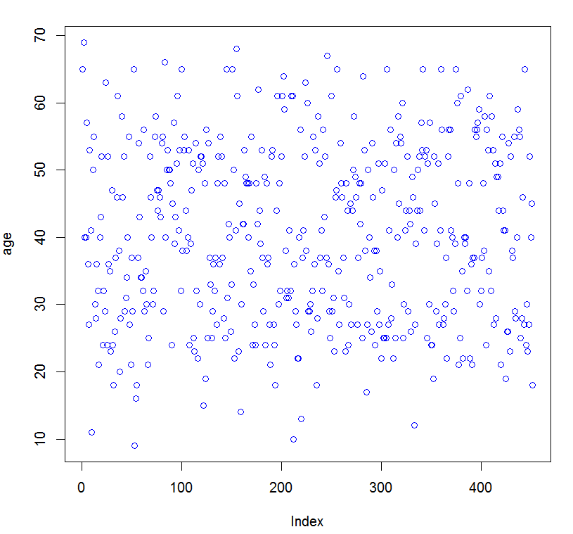

Figure 2: scatter plot for age

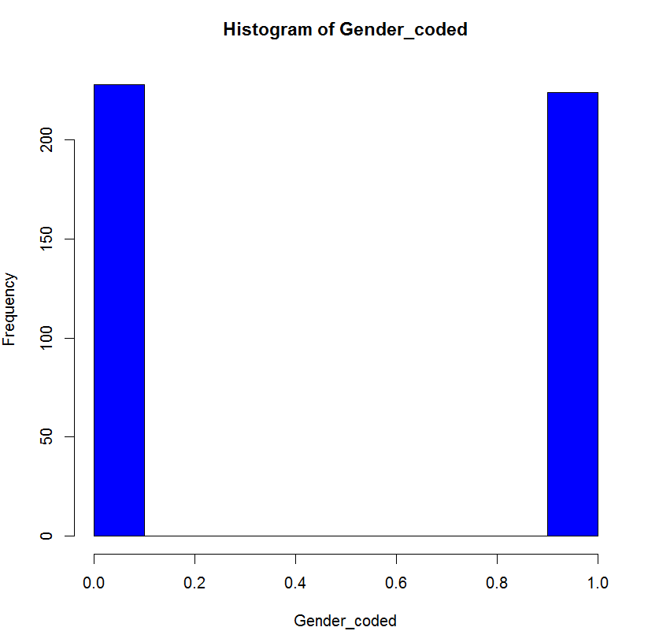

Figure 3: gender histogram (1=female, 0=male)

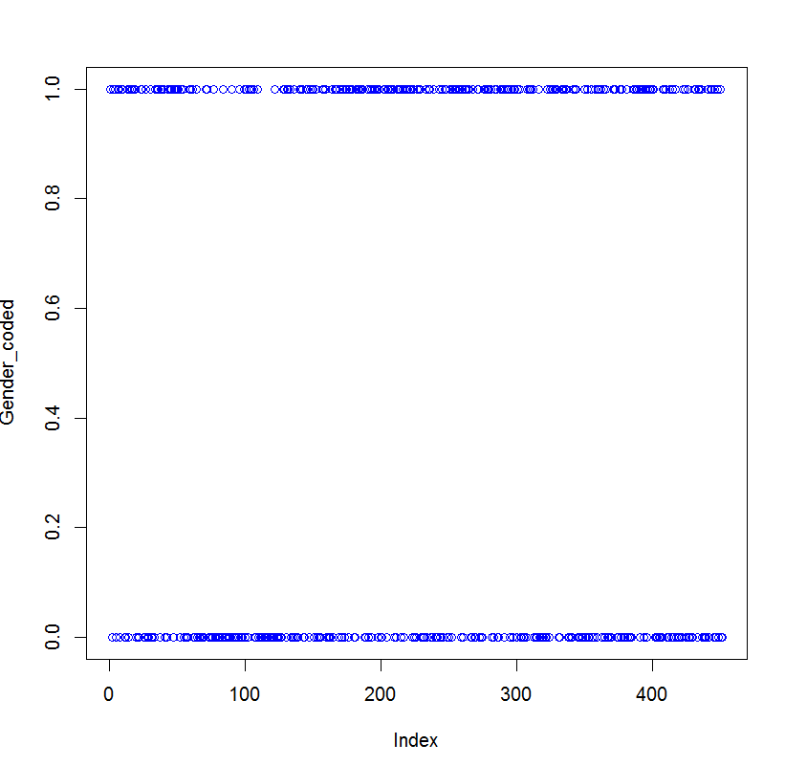

Figure 4: gender scatter plot

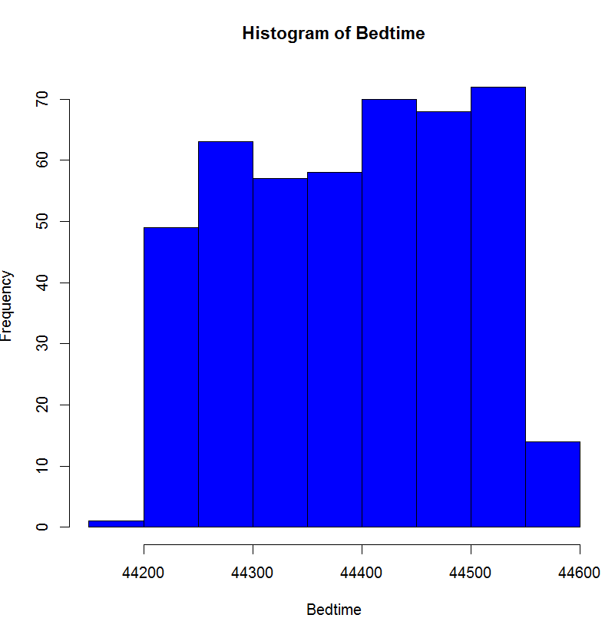

Figure 5: bet time scatter plot

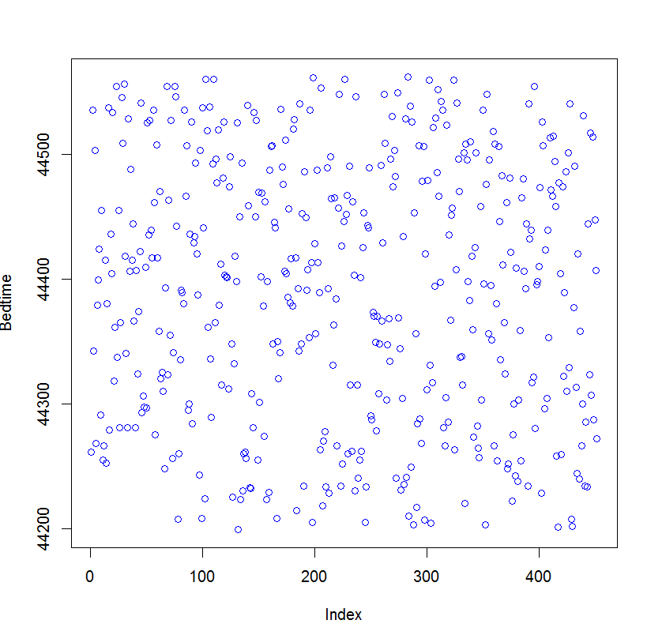

Figure 6: bet time scatter plot

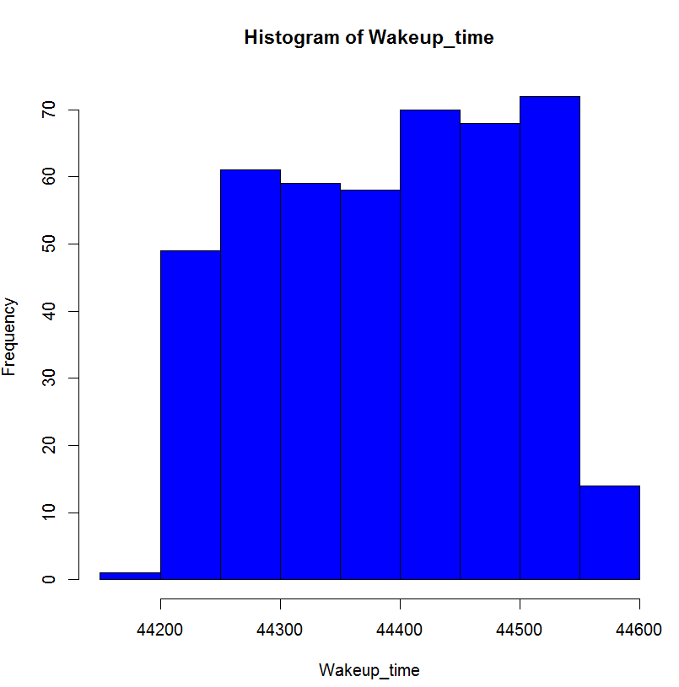

Figure 7: wake up time histogram

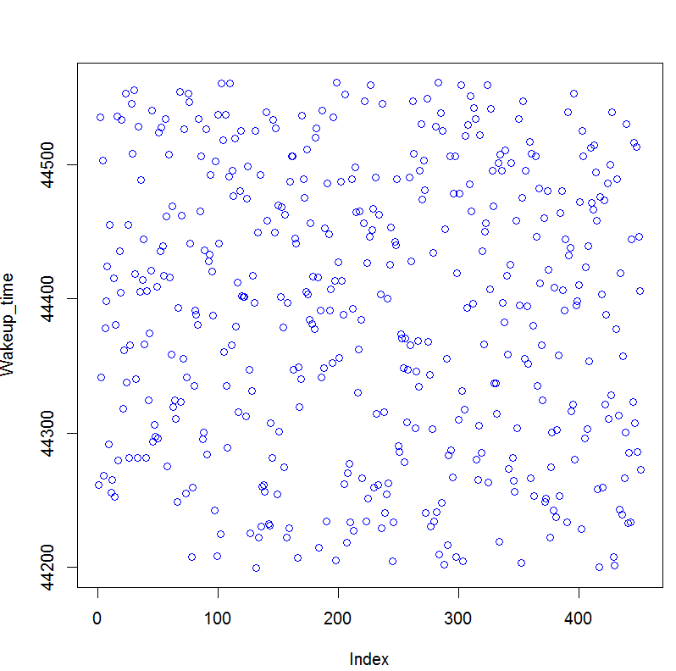

Figure 8: wake up time scatter plot

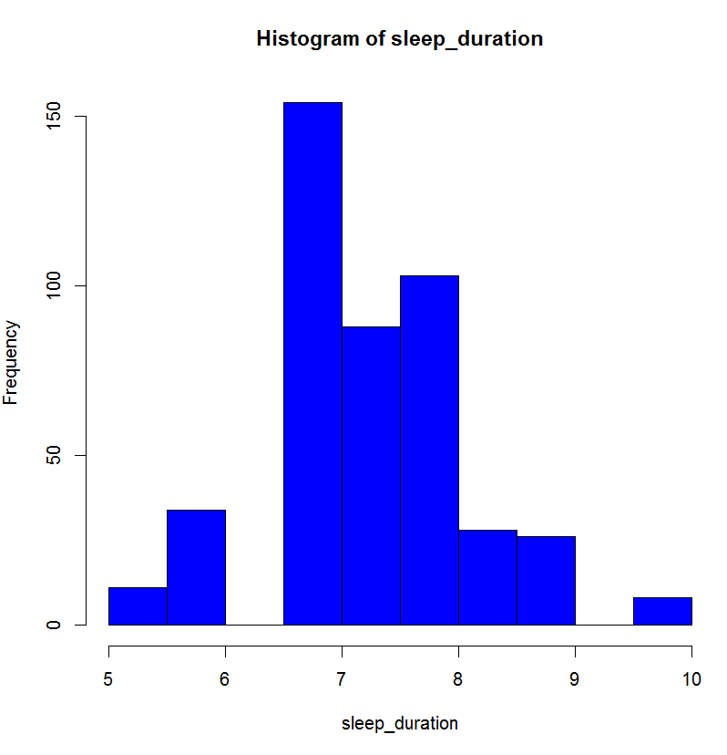

Figure 9: sleep duration histogram

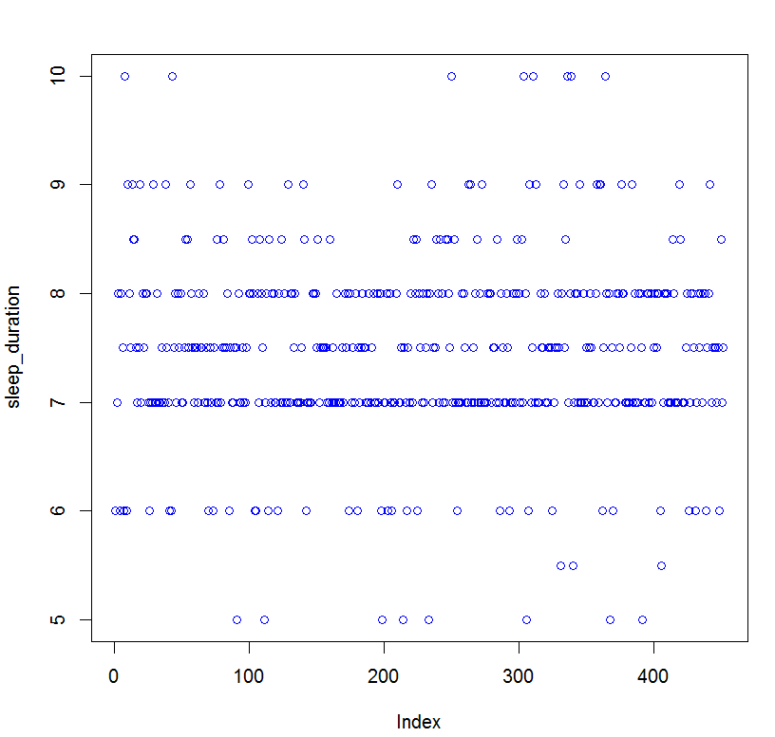

Figure 10: sleep duration scatter plot

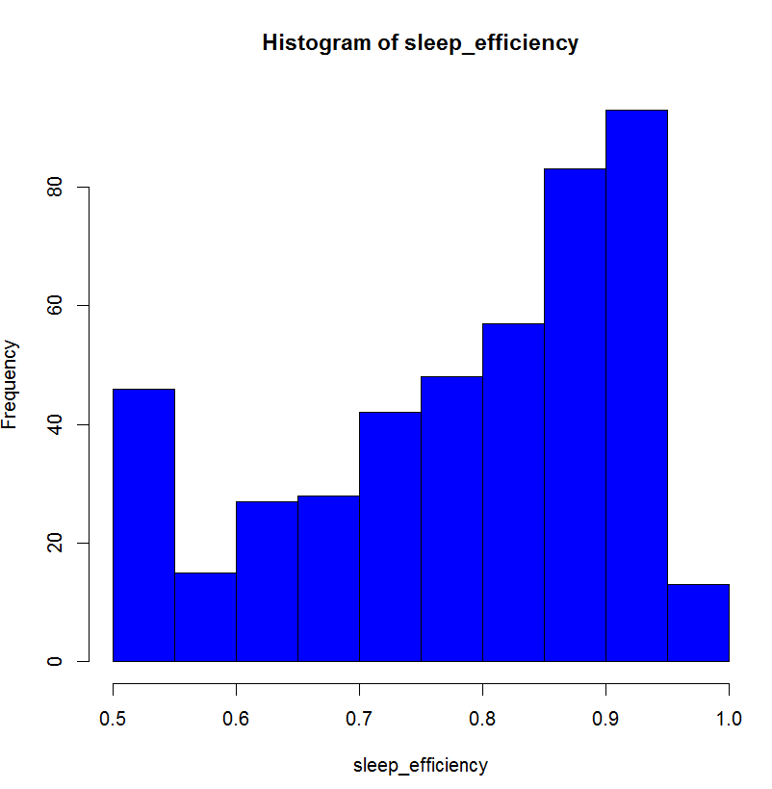

Figure 11: sleep efficiency histogram

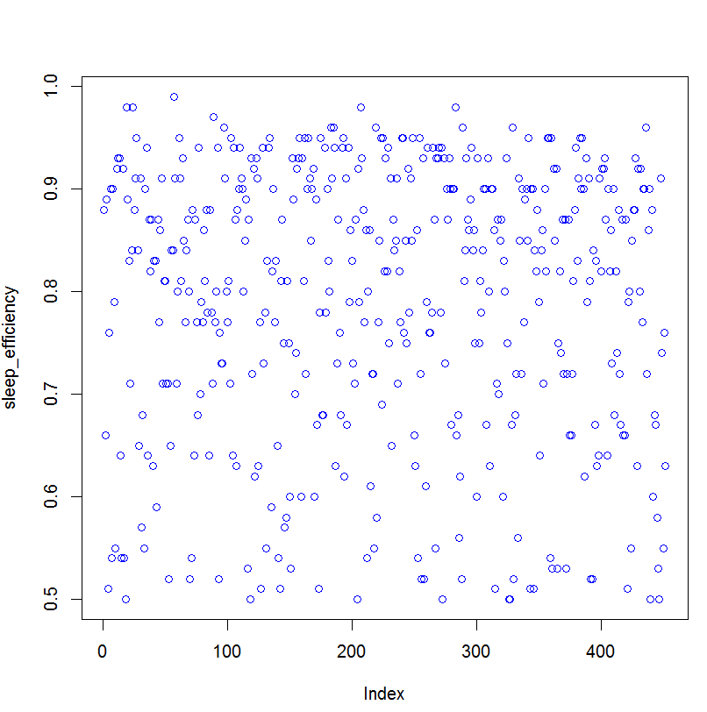

Figure 12: sleep efficiency scatter plot

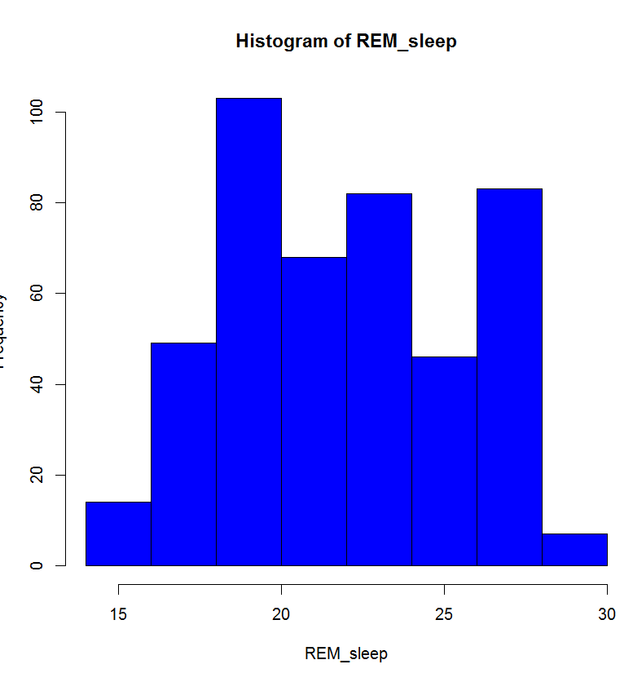

Figure 13: REM sleep histogram

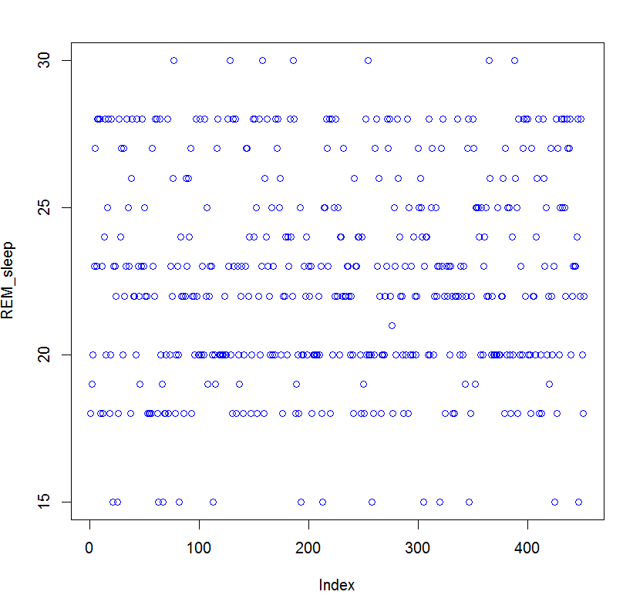

Figure 14: REM sleep scatter plot

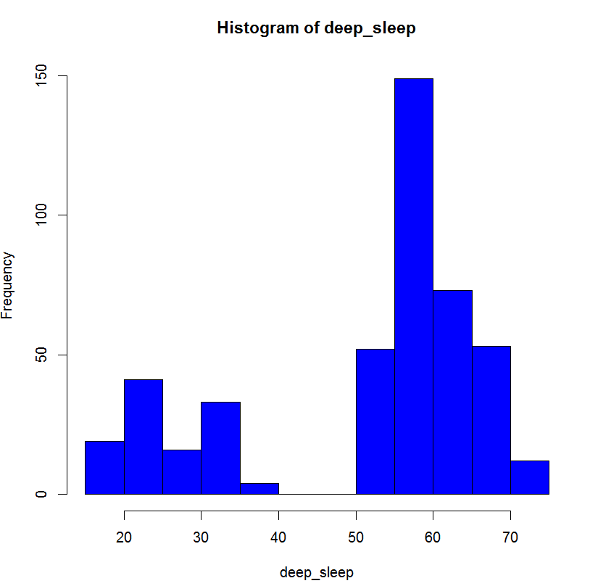

Figure 15: deep sleep histogram

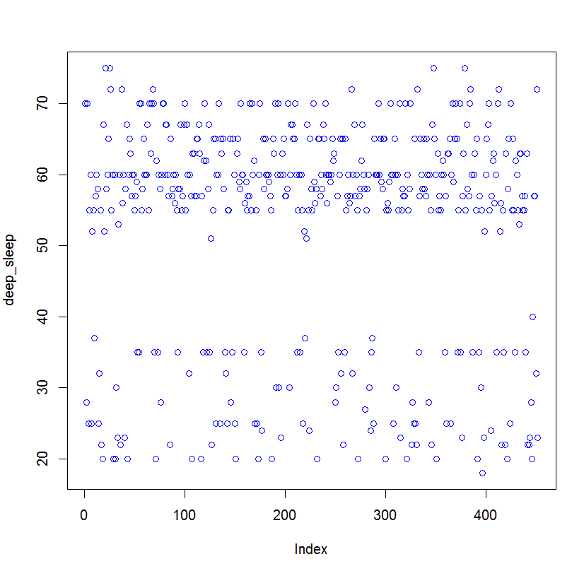

Figure 16: deep sleep scatter plot

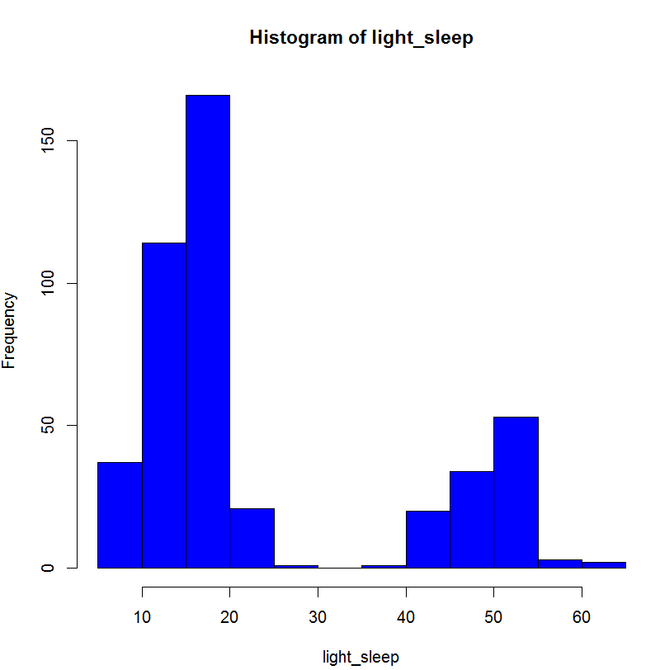

Figure 17: light sleep histogram

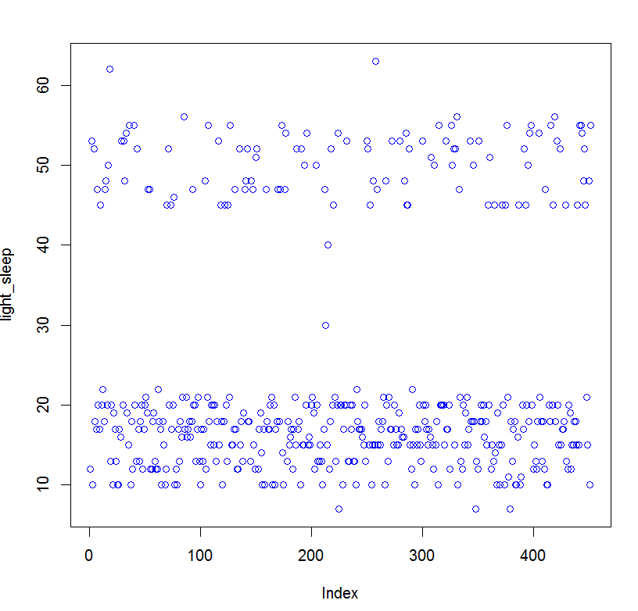

Figure 18: light sleep scatter plot

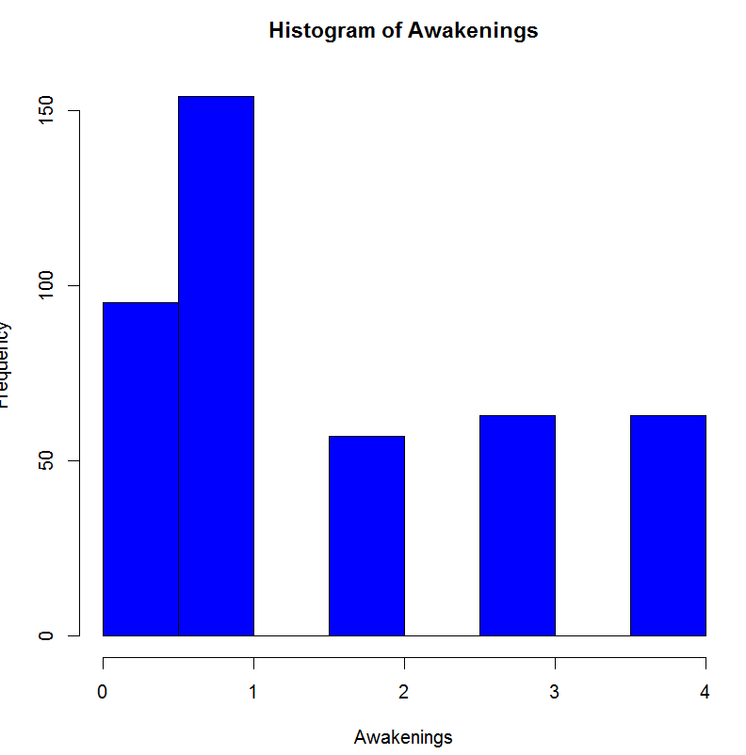

Figure 19: awakenings histogram

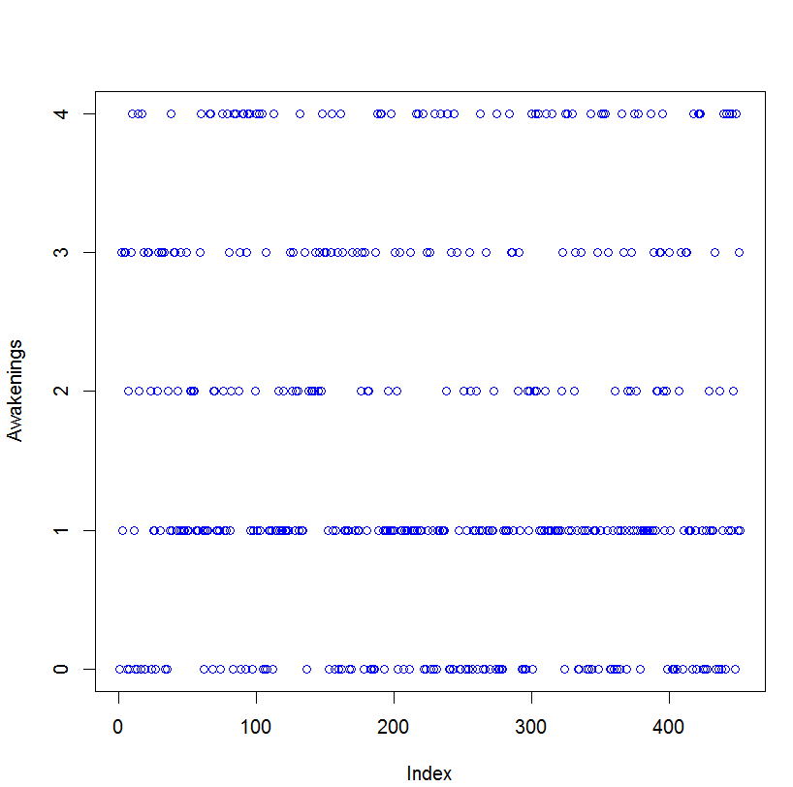

Figure 20: awakenings scatter plot

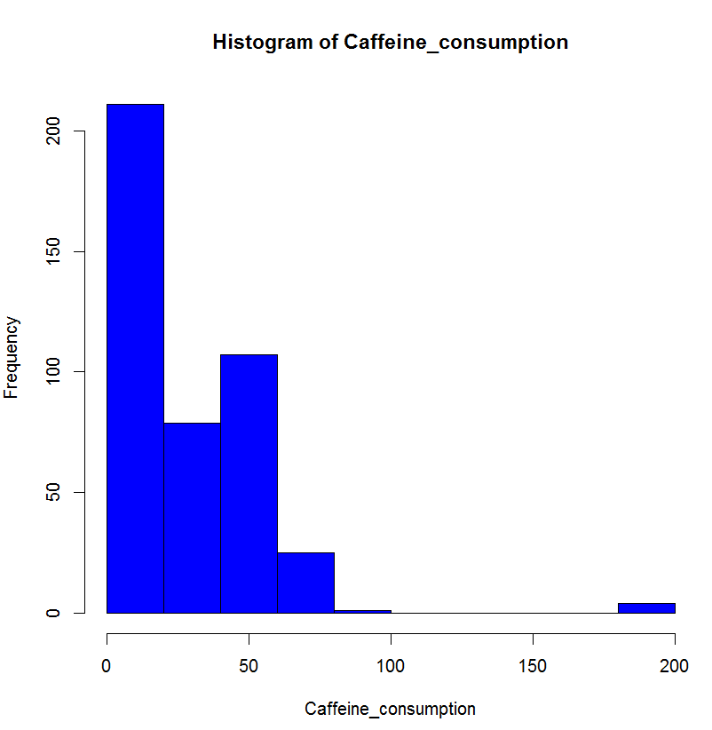

Figure 21: caffeine consumption histogram

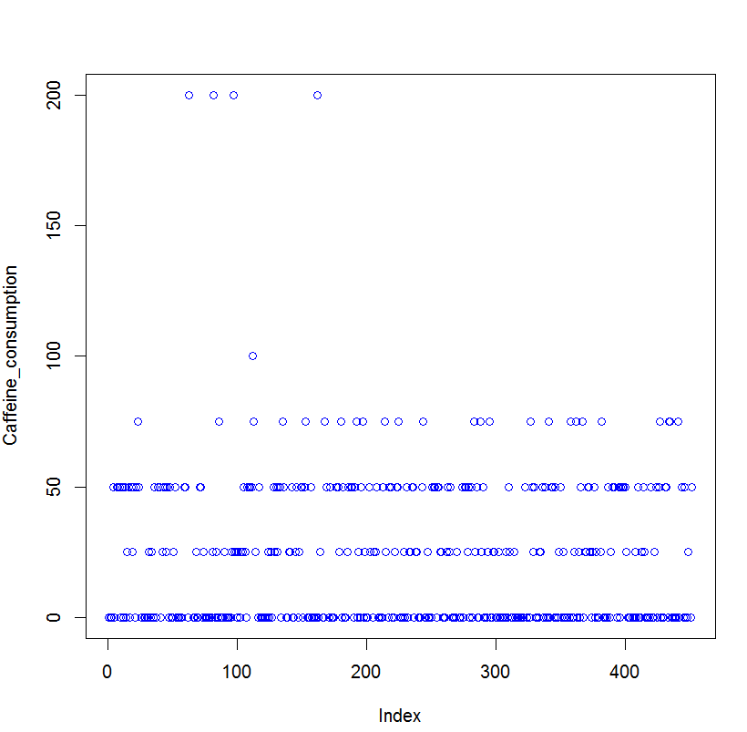

Figure 22: caffeine consumption scatter plot

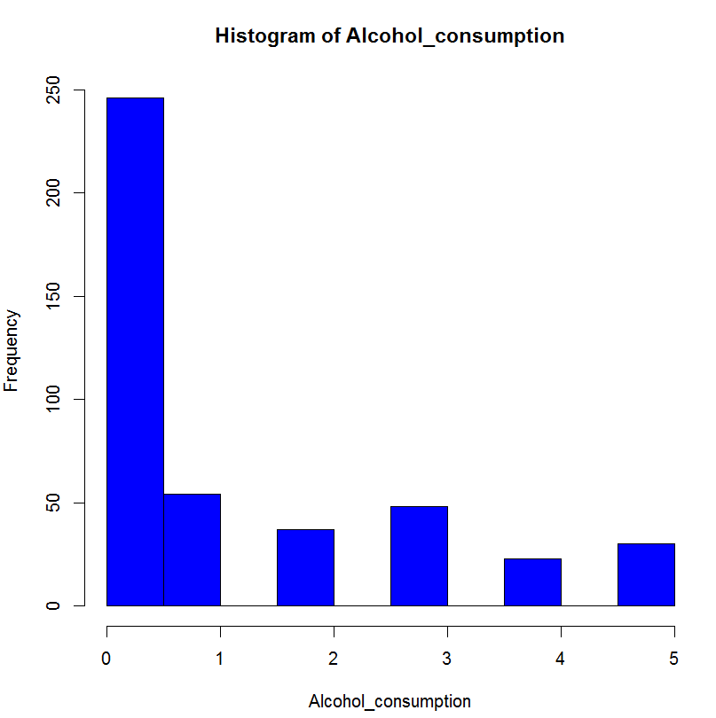

Figure 23: alcohol consumption histogram

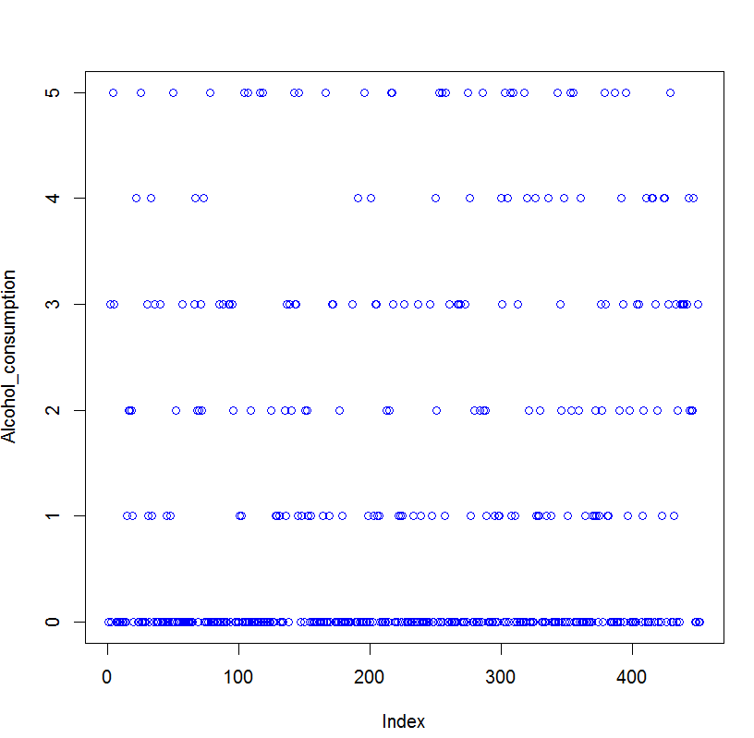

Figure 24: alcohol consumption scatter plot

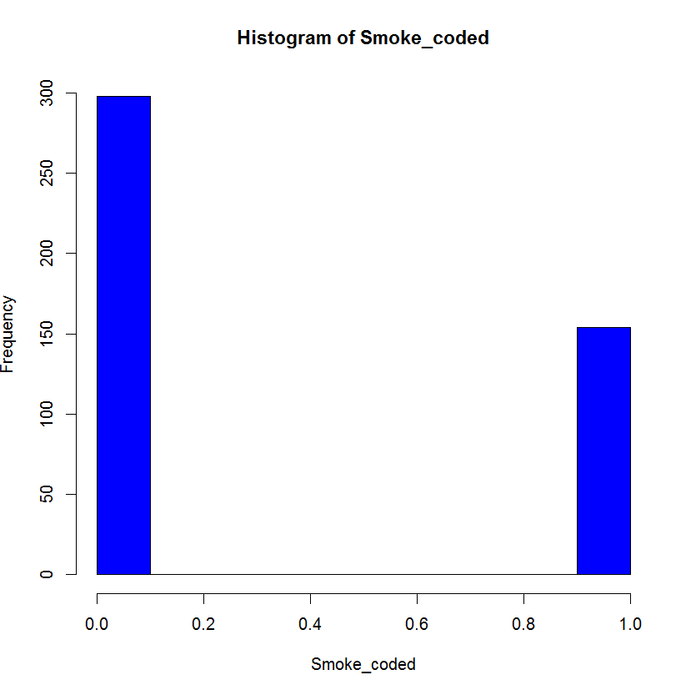

Figure 25: smoking status histogram (1=Yes, 0-No)

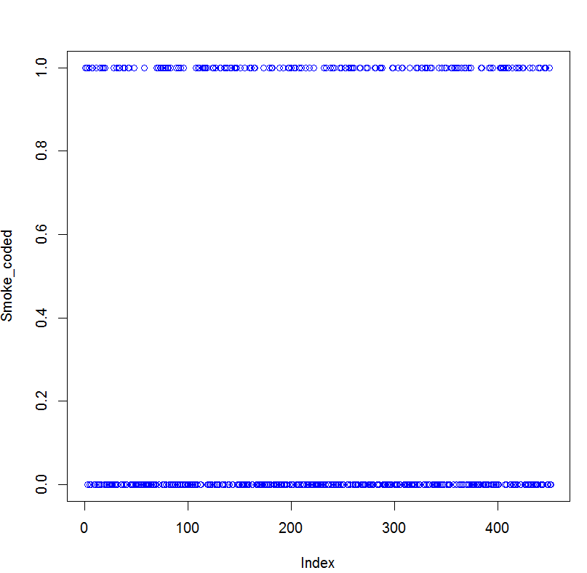

Figure 26: smoking status scatter plot

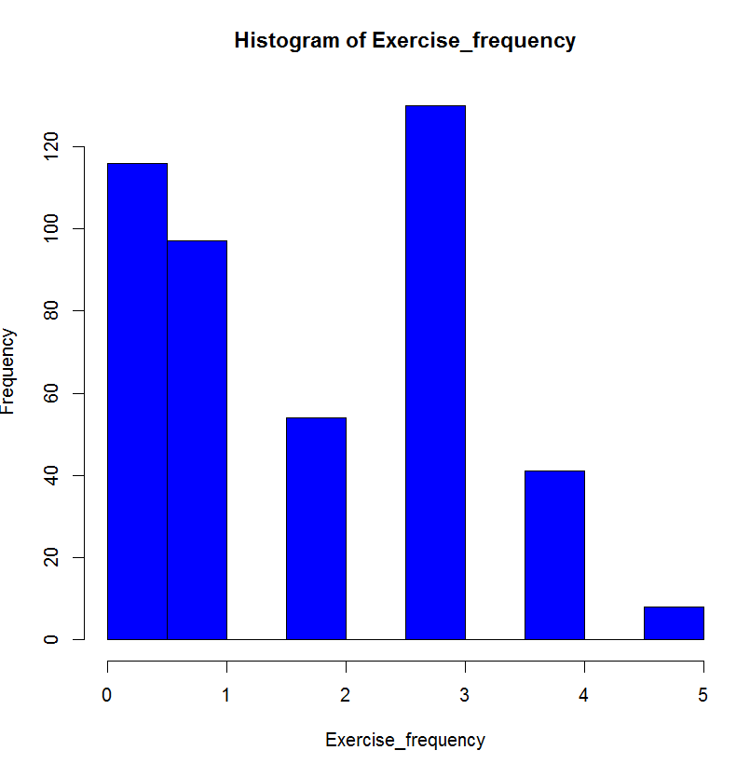

Figure 27: exercise frequency histogram

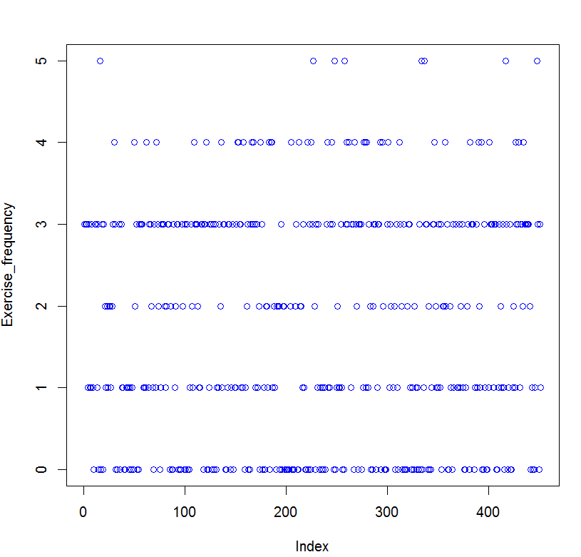

Figure 28: exercise frequency scatter plot

**Research questions**

**1) Is there a relationship between age and sleep efficiency?**

A regression model between age and sleep efficiency was carried out:

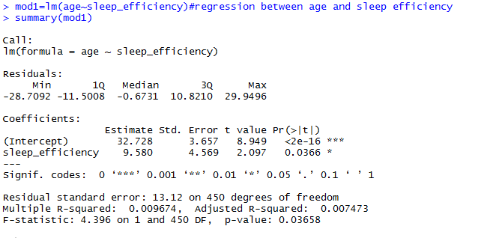

At 0.05 level of significance, the model I significant because the p value of 0.03658 is less than 0.05. Thus, there is a relationship between age and sleep efficiency.

**2) How does the amount of deep sleep percentage vary by gender?**

The deep sleep percentage data was filtered by gender in the R environment. A two sample t test for the resulting subsets was then performed to check for a difference. The results are shown below:

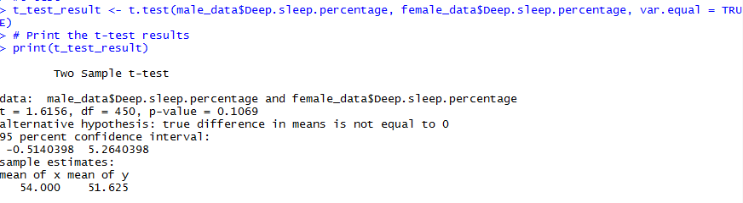

The P value is 0.1069 and is greater than 0.05. This means that the deep sleep percentage is not dependent on gender.

**3) Are people who consume more caffeine likely to experience more awakenings during the night?**

We perform a linear regression between caffeine consumption and the number of awakenings to see if there is a positive correlation.

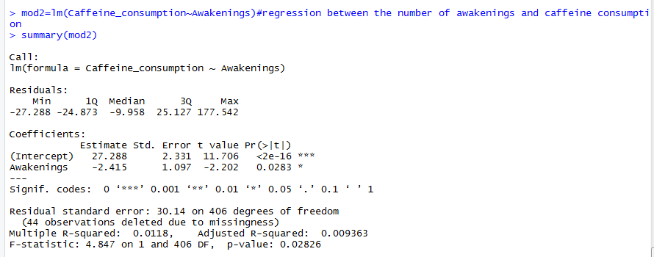

The p value is 0.02826 which is less than 0.05 so the regression is significant. The correlation coefficient is negative which means that people who consume caffeine are not more likely to experience awakenings.

**4) Does exercise frequency have an effect on sleep duration?**

We perform a linear regression between sleep duration and the frequency of exercise to determine if there is a positive correlation.

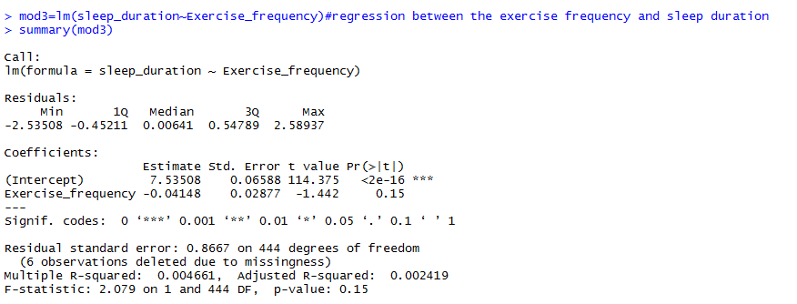

The p value is 0.15 which is greater than 0.05 so the model is not significant means that the exercise frequency does not have a significant effect on sleep duration.

**5) Can we predict sleep duration based on caffeine and alcohol consumption?**

We perform a linear regression between the sleep duration, caffeine consumption and alcohol consumption.

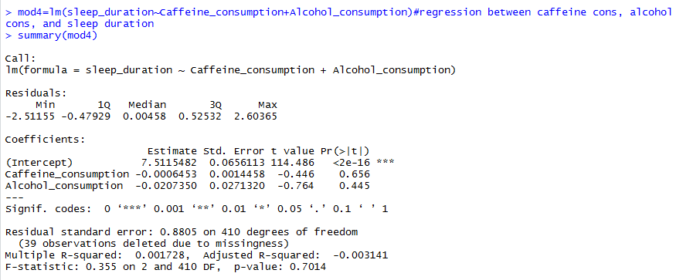

The p value is 0.7014 and is greater than 0.05. This means that the model is not significant and we cannot predict the sleep duration from the caffeine and alcohol consumption.

**6) Does smoking status impact REM sleep percentage?**

We divide the REM sleep percentage data by smoking status and then perform a two sample t test between the two resulting subsets.

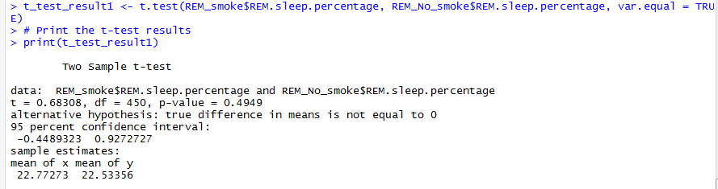

The p value is 0.4949 which is larger than 0.05. This means that the results are not significant and thus, smoking status does not impact REM sleep percentage.

**7) What is the average bedtime and wakeup time for the study population?**

The averages of the two are shown in the image below:



**8) Is there a relationship between age and the number of awakenings during the night?**

We perform a regression between age and the number of awakenings:

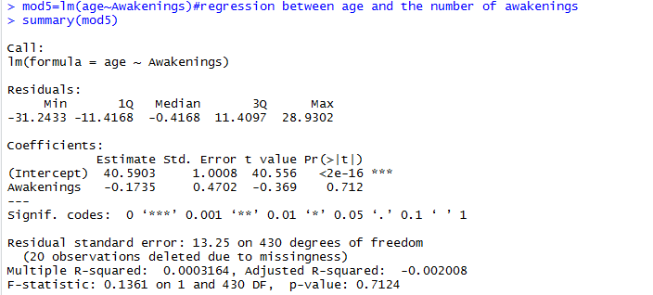

The p value is 0.7124 and is greater than 0.05. This means that the results are not significant. There is no relationship between age and the number of awakenings.

**9) Does sleep efficiency differ based on exercise frequency?**

We can easily perform a regression between sleep efficiency and the exercise frequency to determine whether there is a significant correlation.

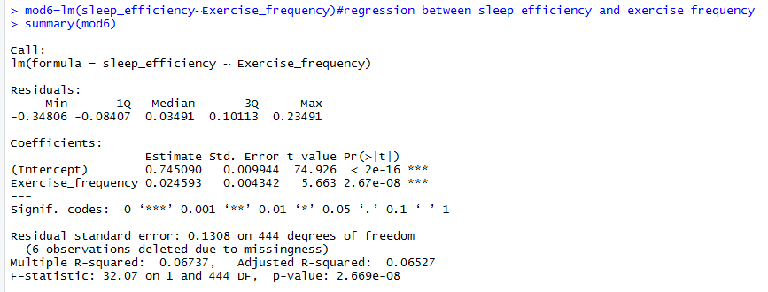

The p value is almost zero. This means that the model is significant and the thus, sleep efficiency differs based on exercise frequency.

**10) Can we predict REM sleep percentage based on deep sleep percentage and light sleep percentage?**

We develop a regression model between these variables and check its significance:

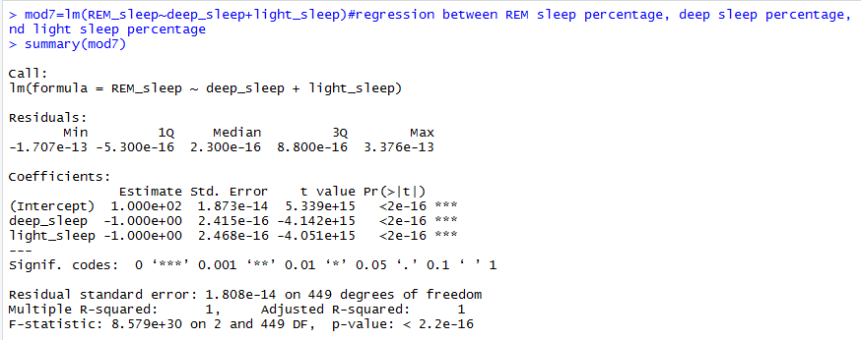

The p value is close to zero which means that the model is significant. We can thus predict REM sleep percentage based on deep sleep percentage and light sleep percentage.

**CONCLUSION**

The statistical analysis showed that there is a significant relationship between age and sleep efficiency, and that caffeine consumption is not associated with an increased likelihood of experiencing awakenings. However, gender, exercise frequency, caffeine and alcohol consumption, smoking status, and age do not appear to have a significant impact on deep sleep percentage, sleep duration, or REM sleep percentage. Additionally, the analysis revealed that sleep efficiency is influenced by exercise frequency, and that REM sleep percentage can be predicted based on deep sleep percentage and light sleep percentage. Overall, these findings can help to improve our understanding of the factors that affect sleep quality and duration.

**REFERENCES**

Brand, S., Gerber, M., Beck, J., Hatzinger, M., Pühse, U., & Holsboer-Trachsler, E. (2015). High exercise levels are related to favorable sleep patterns and psychological functioning in adolescents: A comparison of athletes and controls. Journal of Adolescent Health, 56(6), 563-568.

Drake, C., Roehrs, T., Shambroom, J., & Roth, T. (2013). Caffeine effects on sleep taken 0, 3, or 6 hours before going to bed. Journal of Clinical Sleep Medicine, 9(11), 1195-1200.

Ebrahim, I. O., Shapiro, C. M., Williams, A. J., & Fenwick, P. B. (2013). Alcohol and sleep I: Effects on normal sleep. Alcoholism: Clinical and Experimental Research, 37(4), 539-549.

Liu, Y., Wheaton, A. G., Chapman, D. P., Croft, J. B., & Sleep Quality & Duration Among US Adults: National Health Interview Survey, 2013-2016. (2020). Sleep Health, 6(1), 54-59.

Roehrs, T., Roth, T., & Carskadon, M. A. (2013). Sleep, sleepiness, and caffeine use in adolescence. Pediatrics, 131(5), 1334-1340.

Van Cauter, E., Leproult, R., & Plat, L. (2008). Age-related changes in slow wave sleep and REM sleep and relationship with growth hormone and cortisol levels in healthy men. Journal of the American Medical Association, 300(5), 571-582.

Vgontzas, A. N., Bixler, E. O., Chrousos, G. P., & Pejovic, S. (2004). Obesity and sleep disturbances: meaningful sub-typing of obesity. Archives of Physiology and Biochemistry, 112(5), 263-272.

Yang, P. Y., Ho, K. H., Chen, H. C., & Chien, M. Y. (2017). Exercise training improves sleep quality in middle-aged and older adults with sleep problems: A systematic review. Journal of Physiotherapy, 63(1), 13-20.